**Goal of the Phase 1 which proposed and covered:**

* Audit Planning Module
  + Creating audit definition objects
  + Modifying Audit Definition Objects
  + View Audit Object and Attributes
* Master Data Management
  + User Management
  + Source Reference Object
  + Role Management (Future )
  + Reset Password from Auditors (Future)
* Export Audit Report
* Reporting
* Scheduling Audit Report
* Scheduling Frequency , will make it configurable (Future)

**Used Technologies**:

* **Frontend:** React.js
* **Backend:** Spring-boot
* **Target Database:** MS-Sql
* **Source Database:** Consider Excel File as Source-DB
* **Authentication Service:** oauth2.0 + own JWT token using pem key
* Kafka Producer and Consumer

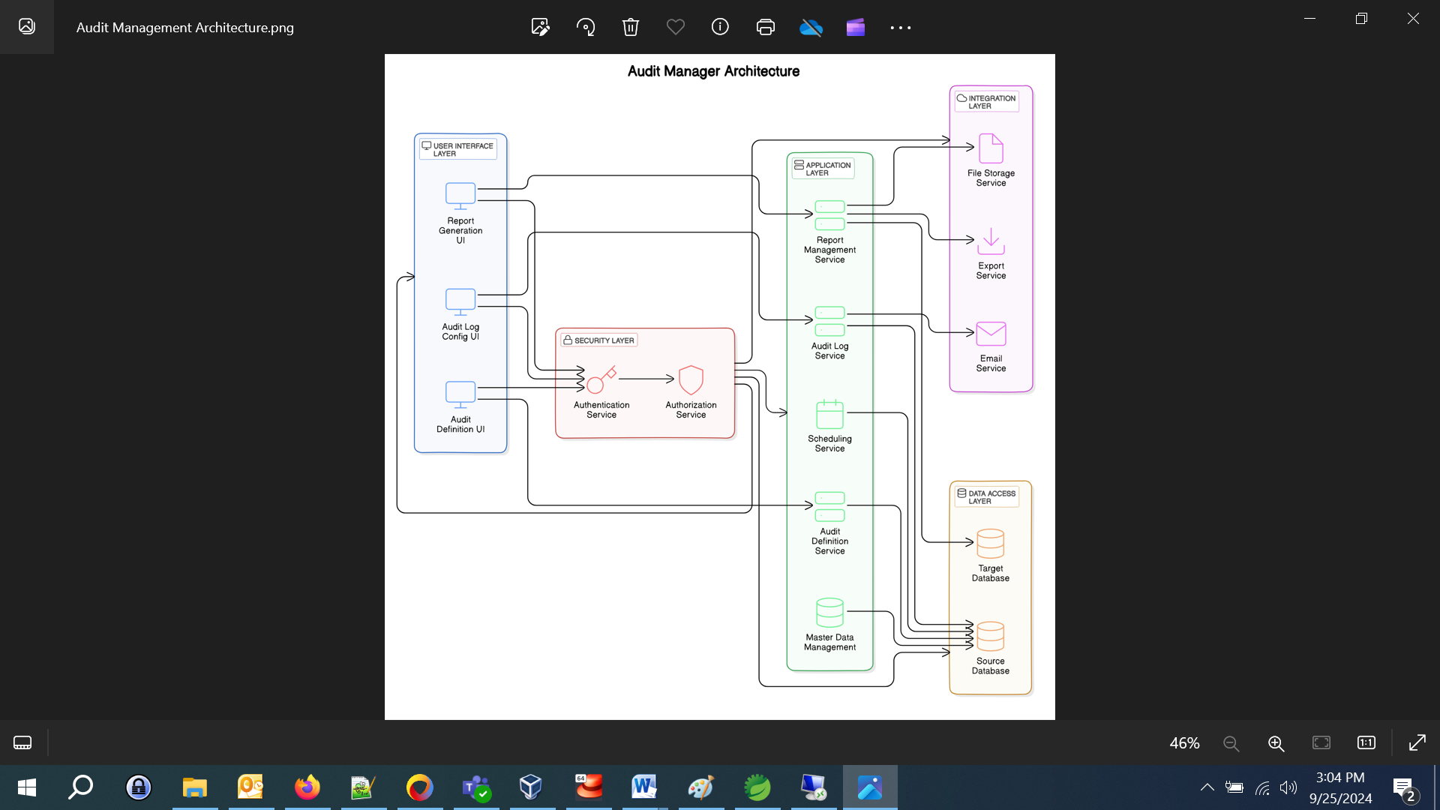

**Phase1 have covered:**

* Microservices
* Authentication
* Swagger Implementation
* Email Integration
* Junit Test Cases
* Kafka Producer Consumer with Zookeeper and Kafka Server
* Created batch file to hit the Kafka P-C on Server
* Functional and Non-functional Test cases
* Selenium Automation Test Scripts
* Deployment on VPN server

**Document’s List for Phase1:**

1. Audit Management Software Design
2. Developer Guide for Audit Management Web Application
3. User Manual for Audit Management Web Application
4. Test Cases for Audit Management Web Application
5. Kafka Integration Audit_Manager Application
6. Deployment Guide
7. Automation Test case
8. Test Case Result

**Phase2 will cover:**

* + Role Management
  + Status as Active/ Deactive for User Management
  + Reset Password from Auditors
  + Scheduling Audit Report: Scheduling Frequency , will make it configurable
  + Cloud-Based Solutions: Utilize cloud platforms for scalable storage and management of audit data
  + Any improvements from client